Australian Islamic College 2018

ATAR Chemistry Units 3 and 4

Task 5 (Weighting: 3%)

Volumetric Analysis Test

Test Time: 30 minutes

Please do not turn this page until instructed to do so.

First Name | Surname

Teacher

Mark / 21 | Percentage

Equipment allowed: Pens, pencils, erasers, whiteout, rulers and non-programmable calculators permitted by the Schools Curriculum and Standards Authority.

Special condition: 2 marks will be deducted for failing to write your full name on this test paper.

Teacher help: Your teacher can only help you during your test in one situation.
If you believe there is a mistake in a question show your teacher and your teacher will tell you whether or not there is a mistake in the question and if appropriate, how to fix that mistake.

Questions must be answered in this booklet, in the spaces provided.

Total marks: 21

- In a titration to determine the concentration of a hydrochloric acid solution using a sodium hydroxide standard solution the following results were collected.

 | Trial 1 | Trial 2 | Trial 3 | Trial 4 | Trial 5
Initial burette reading (mL) | 0.0 | 3.6 | 10.2 | 5.5 | 4.4
Final burette reading (mL) | 25.3 | 27.6 | 34.3 | 31.6 | 28.6
Titre (mL)

What average value for the titre should be used for the calculations of the hydrochloric acid concentration? [1 mark]

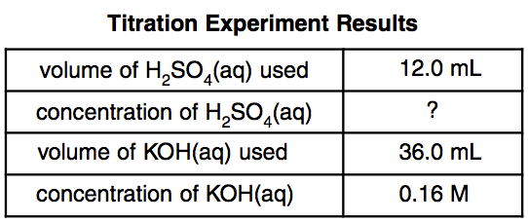
- The table above summarises the results of a titration.
  - Name the analyte. [1 mark]

  - Name the standard solution. [1 mark]

  - State one reason why the substance you named in part (b) is unlikely to have been the primary standard solution. [1 mark]

  - Determine the concentration of the analyte. Express your answer to the appropriate number of significant figures. [1 mark]

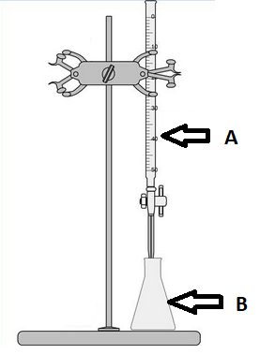

- All of Question 3 refers to the diagram above.
  - What is the name of the piece of equipment labelled ‘A’?
[1 mark]

  - With what should the final rinse of the piece of equipment labelled ‘B’ be performed? [1 mark]

  - What word describes the measured volume of liquid dispensed from ‘A’ to reach the endpoint? [1 mark]

  - How is the endpoint typically recognised during an acid-base titration such as the ones performed in our classroom? [1 mark]

  - How will the final calculation of analyte concentration be affected if, every time a titration is performed, the volumes in equipment ‘A’ are measured from the top of the meniscus instead of the bottom of the meniscus? Justify your answer. [2 marks]

  - When preparing for a titration using the equipment above 1.54 g of primary standard was dissolved in 250 mL of distilled water instead of 1.45 g, as intended.
    - What type of error will this cause? Circle the correct answer from the three choices below. [1 mark]

Systematic / Random / No error

    - How will the final calculation of analyte concentration differ from the true value? Circle the correct answer from the three choices below. [1 mark]

Too high / Too low / No change

  - The equipment shown in the diagram at the start of this question was used to perform a titration. Hydrochloric acid was placed in the burette and a solution of sodium hydrogen carbonate was placed in the conical flask.
Sketch the titration curve on the grid below, label the vertical axis (Y-axis) appropriately and label the equivalence point.
[4 marks]

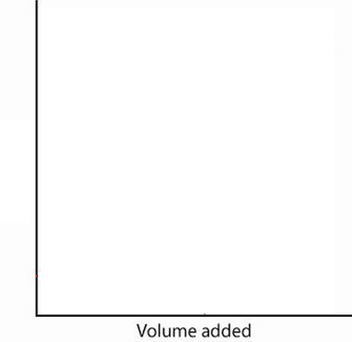

- To determine the purity of a sample of copper(II) oxide, a 20.56 g sample of the impure substance was reacted with 500.0 mL of 1.10 mol L⁻¹ hydrochloric acid, an excess. After this reaction was complete a 25 mL aliquot of the acid was titrated against a standard solution of 0.100 mol L⁻¹ NaOH. An average titre of 25.4 mL was required to reach the endpoint.
Determine the percentage purity of the copper(II) oxide and express your answer to the appropriate number of significant figures. [4 marks]

END OF TEST

